Monthly Progress Report for the Month of November 2018
(Ist day to last day of the month)
Name of the KVK: KULGAM

1. Details of On Farm Trials (OFT) -
S. No | Title of OFT | Crop  (Variety) | Date of execution | Date of completion |  | Achievements
 |  |  |  |  | Area (ha)/No | No. of Beneficiaries
 |  |  |  |  |  | SC/ST |  | OBC |  | Others |  | Total
 |  |  |  |  |  | M | F | M | F | M | F | M | F
1 | Assessment of nutritional management practices for improvement of productive and reproductive performance in dairy cow | Cross bred Jersey cow | 1-3-2018 | continue | 12 No |  |  |  |  | 12 |  | 12
2 | Clinical Management of foot rot | Sheep | 27-6-2017 | continue | 12 No |  |  |  |  | 12 |  | 12
3 | Assessing the performance of Potassium Permanganate as preventive measures for subclinical Mastitis in milking cows | Cross bred Jersey cow | 01-03-2018 | Continue | 12 No |  |  |  |  | 12 |  | 12
4 | Varietal Assessment of oats varieties released by SKUAST-K | SKO-20  SKO-90 | 12/10/18 | continue | 5 |  |  |  |  | 5 |  | 5

2 Details of Frontline Demonstrations (FLDs) -
Crop  (Variety) | Title of FLD | Date of execution | Date of completion |  | Achievements
 |  |  |  | Area (ha) | No. of Beneficiaries
 |  |  |  |  | SC/ST |  | OBC |  | Others |  | Total
 |  |  |  |  | M | F | M | F | M | F | M | F
Oats  (SKO 96) | Improved variety of fodder oat to augment fodder production in district Kulgam | 6/10/18 to 12/10/18 | Conti. | 21.6 | - | - | 23 | - | 42 | - | 65 | -
Brown Sarson | Yield advantage with Shalimar Brownsarson-1 | 6 to 12 October | Conti. | 8.4 |  |  | 6 |  | 15 |  | 21 | -
Backyard poultry rearing | Vanraja / Kroiler poultry birds as backyard poultry | 12/6/18 | Conti. | 10 demonstrations
Sheep | Oral administration of recommend dose of (Albendazole750mg+ivermectin25mg/30ml)  Prevention and control of parasitic diseases of small ruminants by de-worming  (50 animals) | 1-3-18 | Conti. | 50 sheep | 10 |  | 20 |  | 20 |  | 50 | -

2.1Field days/KisanGosthis organized under FLDs during the reported month-
Name of  Activity | Achievements
Name of  Activity | No. of  Activity | No. of Beneficiaries
Name of  Activity | No. of  Activity | SC/ST |  | OBC |  | Others |  | Total
Name of  Activity | No. of  Activity | M | F | M | F | M | F | M | F
Field Day
KisanGosthi

2.2 Diagnostic Services during the reported month–
Particulars | Achievements
Particulars | No. of visits | No. of Beneficiaries
Particulars | No. of visits | SC/ST |  | OBC |  | Others |  | Total
Particulars | No. of visits | M | F | M | F | M | F | M | F
Scientists’ visit to farmers’ fields | 6 | 22 | - | 350 | 6 | 41 | - | 413 | 6
Farmers’ visit to KVK | 77 | 2 | - | 9 | - | 66 | - | 77 | 77

3. Trainings conducted during the reported month
S. No. | Trainees | Title of the training | Date | No. of Participants
 |  |  |  | SC/ST |  | OBC |  | Others |  | Total
 |  |  |  | M | F | M | F | M | F | M | F
 | Crop production | Repairing the damaged fruit plants due to un timely snowfall. | 5,6, 8,9 and 10 November | 22 | - | 338 | 6 | 41 | - | 401 | 6
 | Backyard poultry farmers | Farmer Scientist Interaction programme | 15 November | - | - | 10 | - | - | - | 10 | -
 | Rural Youths’/ School Dropouts’ training
 | In-service training/Extension Personnel
4. Skill Development programme (16 hours and less than 200 hours) conducted during the reported month
S. No. | Title of the Training | Date | No. of days | No. of Participants
 |  |  |  | SC/ST |  | OBC |  | Others |  | Total
 |  |  |  | M | F | M | F | M | F | M | F
1 | Soil sampling and soil sample analysis through STFR for B.Sc. Horticulture students under RAWE | 13,14 and 27 November | 3 |  |  |  |  | 4 | 3 | 4 | 3

4.1 Skill Development programme (200 hours and above) conducted during the reported month
S. No. | Title of the Training | Date | No. of days | No. of Participants
 |  |  |  | SC/ST |  | OBC |  | Others |  | Total
 |  |  |  | M | F | M | F | M | F | M | F
5.Other extension activities carried out during the reported month
Activity |  | Achievements |  |  |  |  |  |  |  | Extension personnel
Activity | No. | No. of beneficiaries
Activity | No. | SC/ST |  | OBC |  | Others |  | Total
 |  | M | F | M | F | M | F | M | F | M | F
Exposure visits of farmers by KVK to other place
Exposure visits of farmers at KVK
Animal camps
Agricultural camps
Other result / method demonstrations | 12 | 0 | 0 | 0 | 0 | 25 | - | 25 | -
Extension literature distributed
Kisangosthi (other than FLDs)
Field Days (other than FLDs)
Farmer scientist interaction
Lecture delivered
Exhibitions
Film show
KisanMela
TV talk
Radio talk
Publications
Extension literature
Magazines/Newsletters
Papers/Articles
Reports | 1
Press releases | 1
Technology Week
Important days
6. Other activities during the reported month-
Particular | Achievements
Training received by staff of KVK (No.) | -
Revenue generated from sale of produce (Rs.) | Rs. 14580/=

7. Details of samples analyzed during the reported month
Details | Through Soil Water lab |  |  |  | Through Mini Soil Water lab Kit
Details | No. | No. of Farmers | No. of Villages | Amount realized (Rs.) | No. | No. of Farmers | No. of Villages | Amount realized (Rs.)
Soil Samples tested
Soil Health card issued
Water Sample analysed
8. Messages sent throught M-Kisan Portal during the reported month
Mobile Advisory
S. No. | No. of farmers  Covered | Messages | Write the message sent through M-Kisan Portal

9. Crop-wise seed produced during the reported month
Crop | Name of the Crop /Breed | Quantity (in quintals) | No. of farmers
Crop | Name of the Crop /Breed | Quantity (in quintals) | SC/ST | OBC | Others | Total
Cereals | Rice, Maize | 17 | -- | -- | -- | --
Oilseed | Soybean | 5 | To be distributed during next season
Pulses |  | --
Any Others |  | --

10. Crop-wise saplings produced during the reported month
Crop | Name of the Crop/ variety | Quantity (in Numbers) | No. of farmers
Crop | Name of the Crop/ variety | Quantity (in Numbers) | SC/ST | OBC | Others | Total
Vegetables Seedling
Fruits
Flowers
Fodder
Any others

11. Live-stock strains and finger lings produced during the reported month
Sr. No. | Particulars | No. of farmers
Sr. No. | Particulars | SC/ST | OBC | Others | Total
1 | Newly born calf | - | - | - | -
2 | Poultry birds | - | - | - | -

12.A. Details of programmes conducted in soil health during the reported month
S. No. | Activity/Action Plan | No. of Program | No. of Participants | Thematic Areas/agri enterprises/proven technologies/crops, animal etc.
1. | Interventions of KVK having soil testing facility to provide technological backstopping on soil health cards to Agriculture Departments at district level.
1. | - Training to extension personnel
1. | - Advisories to farmers | - | 23 | Soil health
1. | - Any other intervention (please specify)  Method demonstrations for soil sampling technique | 10 | 25 | Soil health
2. | Training of Rural youths/farmers in the soil and water management at KVKs | 1 | 7 | Soil health
3. | Training on collection of soil samples to
3. | - Farmers
3. | - Extension personnel
4. | Training of farmers on
4. | - Balanced use of fertilizer
4. | - Integrated Nutrient Management
4. | - Liquid Fertilizer
12.B: Other activities
S. No. | Activity/Action Plan | No. of Programmes | No. of Participants | Thematic Areas/agri enterprises/proven technologies/crops, animal etc.
1. | Animal husbandry programmes/technologies including feeding & management of animals training programme organized | 1 | 10 | Livestock care during winter
 | Resource Conservation
 | - Demonstration on water conservation
 | - Demonstration on micro irrigation

13. Direct Benefit Transfer scheme for the Farmers by KVKs during the month.
S.No. | Parameter | Value (In Rs.)/ Number
1. | Overall budget for FY Year 2018-19  Budget excluding salary component from KVK | 1250000
2. | DBT Applicable Component (OFT, FLD, Training & other extension activities) fund allocation during the month | -
3. | Total No. of Beneficiaries Received funds in kind during the month | -
4. | No. of Beneficiaries records digitized | -
5. | No. of Aadhar authenticated beneficiaries from total number of farmers mentioned during the month | -
6. | No. of Beneficiaries having Mobile No. from total number of farmers mentioned during the month | -

14. SwachhbharatAbhiyan
A) Activities undertaken under Swachh Bharat Abhiyan during the month
S. No. | Action point | Activities undertaken (Describe in bullet form only)
 | Basic maintenance | - Cleaning of Administrative block  - Cleaning of KVK premises
 | Sanitation and SWM
 | Cleaning and beautification of surrounding areas
 | Vermi - composting/composting of biodegradable waste management | - Composting of material obtained from dairy unit and crop residues
 | Used water for agriculture/ horticulture application
 | Swachhata awareness at local level | - Discussion and debate
 | Any other (mention the activities)
B) Total Expenditure underSwachh Bharat Abhiyan during the month(Any activity undertaken by KVK towards maintaining cleanliness should be reported towards expenditure on Swachh Bharat Action Plan).
S. No. | Particulars | Expenditure (Rs)
 | Up-keeping of office and residential campus | Rs.3500
 | House-keeping of KVK Guest House and other such facilities
 | Up-keeping of KVK farm | Rs. 1700/=
 | Recycling of waste material towards reducing garbage and maintaining cleanliness, composting, etc. | Rs.1000/=
 | Expenditure related to any other activity that is taken-up by KVK towards cleanliness, maintenance, white wash, etc. | Rs. 1200/=
 | Total | 7400/=

15. Important events conducted by your KVK during the reported month

- Brief Report
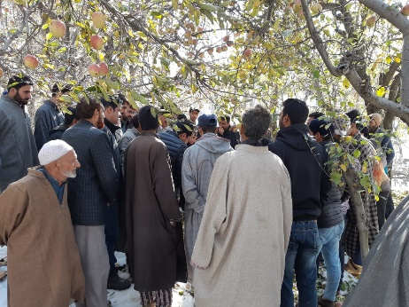
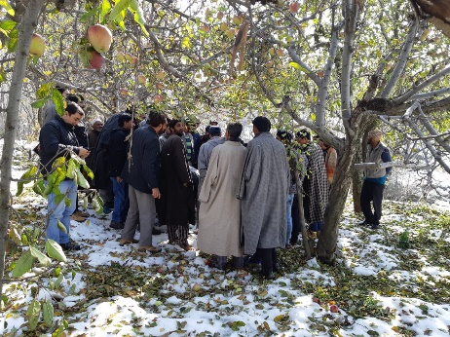
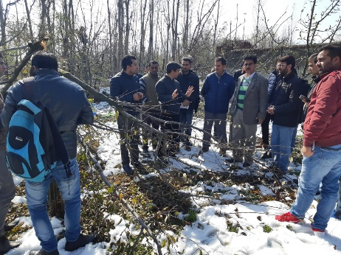
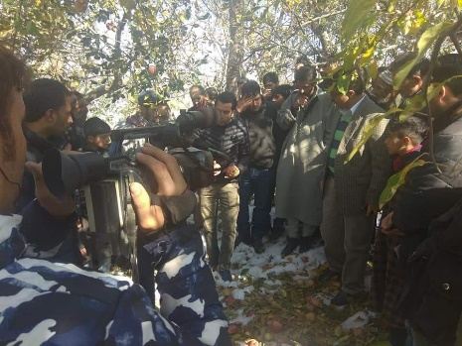
As a part of campaign after recent snowfall in valley, Krishi Vigyan Kendra Kulgam as per the instructions received from University authorities conducted one week filed visit cum training programmes w.e.f 6/11/2018 in district Kulgam. The highlights of programme as under;
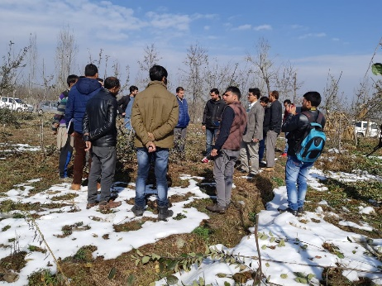
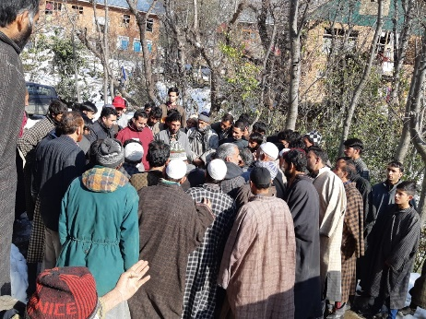
- Scientist team of KVK Kulgam visited the high altitude and far-flung area of district Kulgam along with the team of officers from line department.
- Worthy District Development Commissioner Kulgam Dr. Shamim Ahmad, SDM, Tehsildars Chief Horticulture Officer Kulgam and other officials of horticulture and revenue department also participated during the programme.
- Number of orchards in 31 villages including Pombay, Devsar, Nihama, Khokharhama, D.H.Pora, Badijhalan, D.K. Mergw, Nagnar, Nagam, Salam Kani, Chimmar, Yaroo, Konsarbal, Hard hanger, Sursana, Monadguffan, Manchoo, Boh, Asnoor, Manzgam, D.H.Pora, Lalpora (Sanyari), Dodwani, watoo, Tangmargh, Damhal, Chogalpora, Bathipora, Areh, Nelow and Modegam were visited by the team.
- During these filed visits following observations were recorded by the Kendra
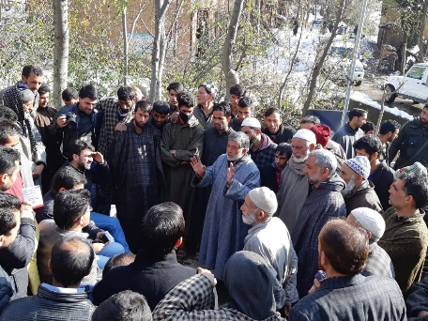
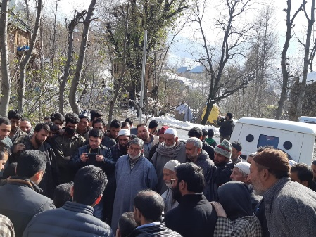
- Un- harvested fruit was seen in some orchards which suffered heavy loss.
- Fruit piled in some orchards was not covered but with snow.
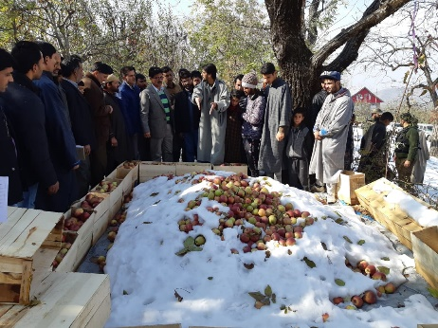
- Damage was quite variable .Famers who managed to clear snow from trees on the date of snowfall have suffered minimum plant damage. Farmers who have trained trees properly (very less in number) have suffered minimum damage. Farmers who have neither trained the trees properly nor removed snow from trees have suffered huge loss.

- On-spot advisory and training was also given by KVK Kulgam scientists to the farmers during the field visits as per the prevailing situation.
- Programme was covered by print and electronic media.

